**KEEZHADI EXCAVATION OBJECTS   
IN AUGMENTED REALITY**

**Project Guide :**

**Mr.J.Duraimurugan**

Name : Dhivagar V

Reg no: 2019272008

Degree: MCA 3rd Year(SS)

**Abstract:**

* Augmented reality (AR) is an enhanced version of the real physical world that is achieved through the use of digital visual elements, sound and delivered via technology.
* Now using this AR technology, we are going to create the artefacts into a virtual object.
* For example, In Keezhadi  excavation site various Artefacts are found like urns, various types of pottery (red utensils, black objects), iron tools, knives, swords and arrows, some stone beads and some gold ornaments. By this project we turn many valuable and damaged antiques into 3D models by using AR.

**INTRODUCTION:**

* Augmented Reality (AR) was introduced as the opposite of virtual reality: instead of immersing the user into a synthesized purely informational environment, the goal of AR is to augment the real world with information handling capabilities.
* Augmented reality (AR) is a field of computer research which deals with the combination of real world and computer generated data. Augmented reality (AR) refers to computer displays that add virtual information to a user's sensory perceptions.
* Combines real and virtual objects in a real environment.

**Problem Statement:**

* Now the archaeological department is releasing their findings in an article or news papers as a news.
* So the valuable antiques are seen only as a 2D element.
* Many interested youngsters in this field will be able to understand the valuable antique’s information and their importance by seeing those things in 3D objects.

**Objective :**

* In an animated visualization, you are asking the reader to follow the progression of information as it moves from one frame to another.
* There are different ways to do this, from narrative stories to videos to a series of images in static form, but all require users to track information and hold it in their memories.
* Added background, sound, texture, colours, lighting, and other attributes to an animation.
* Added Voice Over About the Keezhadi Excavation Objects.

**Architecture:**

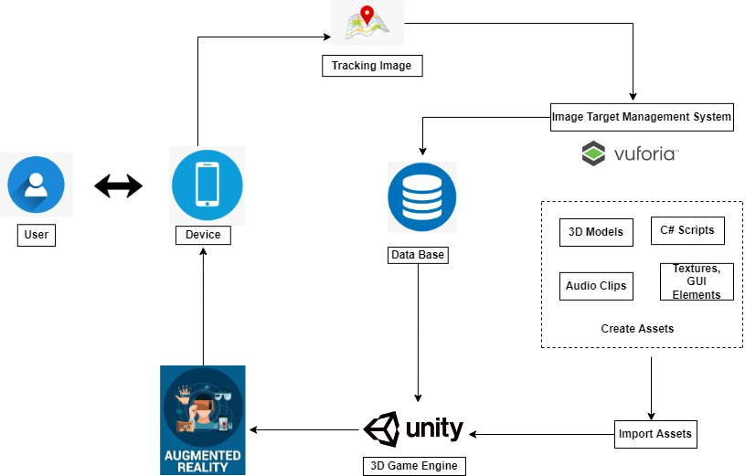

**Design and development process :**

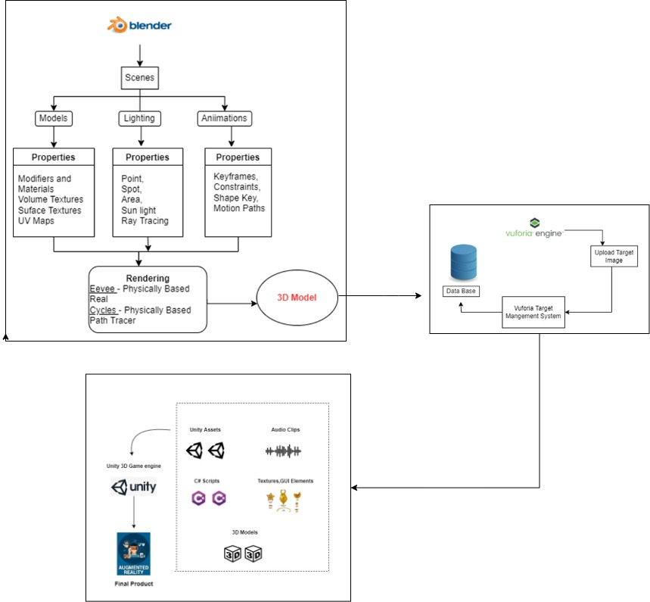

**MODULES**

* Get Information needed
* Image Processing Module
* Rendering Module
* Virtual Object to be Augmented with Unity, Vuforia Interfaces

**Get Information needed:**

To Collecting Information from Tamil Nadu State Department of Archaeology is the archaeology department of the Government of Tamil Nadu. Founded in 1961, the department is headed by an Indian Administrative Service officer with the designation Commissioner for Archaeology and conducts archaeological excavations in the state of Tamil Nadu.

**Image Processing Module:**

AR Camera & Image Target :

* **Vuforia** for this project we decided to go with **Vuforia SDK**in order to enable **AR**instead of unity’s own AR.
* **Vuforia**allows users to easily add advanced computer vision functionality to any application, allowing it to recognize images and objects, and interact with spaces in the real world.
* Instead of using the main camera, in order to enable AR you should add an AR Camera from the **Vuforia**contextual menu.
* The AR camera will allow your camera to recognize certain images (called Image Target) in order to display content above these target images. So along with the AR Camera, we added a Target Image object and added an image to it that will be recognized.

## ****Configuring image targets:**** Image targets trigger the appearance of virtual objects in an augmented reality app. The corresponding target should be specified so that the app recognizes it.

To set up the image targets, move back to the Vuforia Developer Portal and open the [Target Manager](https://developer.vuforia.com/Target-manager) page. Use the **Add Database** button to proceed to the **Create Database** page where you can set up your target image database.

**Rendering Module:**

* Blender is a free, open-source 3D creation suite. It supports the entirety of the 3D pipeline: modeling, rigging, animation, simulation, rendering, compositing and motion tracking, and video editing and game creation.Overall steps for preparing a 3D model with Blender,
* Preparing a 3D model for mixed reality with Blender includes the following steps:

1. Import the model into Blender.
2. Decimate the model.
3. Unwrap the model (UV unwrapping).
4. Assign materials.
5. Bake the textures.
6. Export the model as a GLB file.

There were two rendering module teams in Blender:

• **Render & Cycles:** includes Cycles, Blender render pipeline, color management, materials, textures, etc.

• **Eevee & Viewport**: includes Eevee, 3D viewport drawing, OpenGL & Vulkan

**Virtual Object to be Augmented with Unity, Vuforia Interfaces:**

## **Getting started with Vuforia and Unity3D:** To start your first project with Vuforia and Unity3D, download the Unity3D version that supports Vuforia.

* During the package installation, mark **Vuforia Augmented Reality Support** together with the support of iOS or Android, or both.

After the successful download and installation, create your project in Unity3D.

**Software and Platforms :**

* Unity
* Vuforia SDK
* Blender
* Visual Studio
* Adobe Photoshop
* Audacity

**REFERENCES:**

* [**https://www.udemy.com/course/learn-blender-3d-modeling-for-unity-video-game-development/**](https://www.udemy.com/course/learn-blender-3d-modeling-for-unity-video-game-development/)
* [**https://unity.com/how-to/beginner/using-blender-and-maya-unity**](https://unity.com/how-to/beginner/using-blender-and-maya-unity)
* [**https://www.raywenderlich.com/31539225-creating-reusable-characters-with-blender-and-unity**](https://www.raywenderlich.com/31539225-creating-reusable-characters-with-blender-and-unity)
* [**https://gamedevacademy.org/how-to-import-blender-models-into-unity-your-one-stop-guide/**](https://gamedevacademy.org/how-to-import-blender-models-into-unity-your-one-stop-guide/)